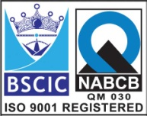****

**“EASCO” Wafer Type Butterfly Valve**

|  |  |  |
| --- | --- | --- |
| **No.** | **Description** | **Material** |
| **1** | Body | ASTM A351 Gr. SS304 |
| **2** | Disc | ASTM A351 Gr. SS304 |
| **3** | Reatiner | SS304 |
| **4** | Seat | PTFE |
| **5** | Shaft | ASTM A-479 type 304 |

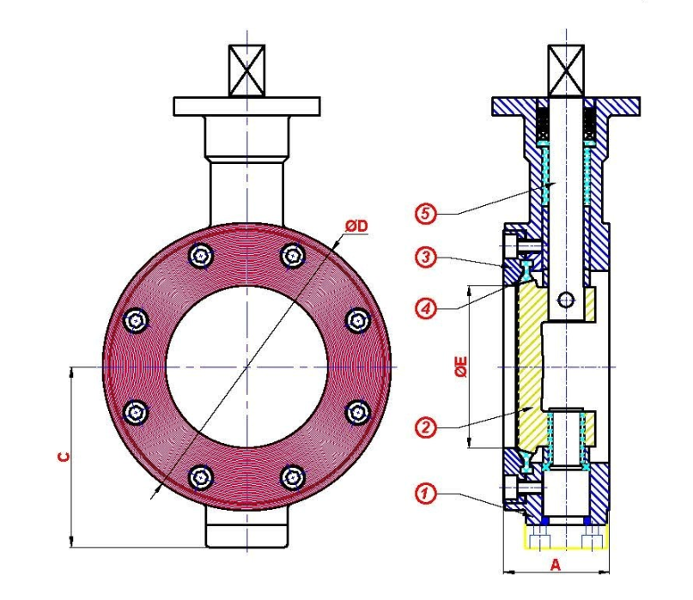 **Part List:-**

**Note:** Size 40mm to 600mm F to F (A) Tolerance is +-3.3

Size 650mm to 900mm F to F (A) Tolerance is +-6.4

**Note:** Size 40mm to 900mm D Tolerance is +-5.0

**Technical Data:-**

|  |  |
| --- | --- |
| Design And Manufacturing | API 609 |
| Valve Face to Face Dimension | API 609 Category “B”/ MS SP-68 |
| Flange Standard Conformity | ANSI B 16.5 Class 150 / ANSI B 16.47 Class 150 (Series A) |
| Inspection & Testing | API 598 |
| Leakage Class | ANSI B 16, 16.104 Leakage Class IV & VI |

**Standard Dimension:-**

|  |  |  |  |  |  |  |  |  |  |  |  |  |  |  |  |  |  |  |  |  |
| --- | --- | --- | --- | --- | --- | --- | --- | --- | --- | --- | --- | --- | --- | --- | --- | --- | --- | --- | --- | --- |
| **Size** | **40** | **50** | **65** | **80** | **100** | **125** | **150** | **200** | **250** | **300** | **350** | **400** | **450** | **500** | **600** | **650** | **700** | **750** | **800** | **900** |
| **A** | 42 | 45 | 48 | 48 | 54 | 57 | 57 | 64 | 72 | 82 | 92 | 102 | 114 | 127 | 154 | 165 | 165 | 190 | 190 | 203 |
| **C** | 57 | 68 | 74 | 80 | 96 | 117 | 132 | 157 | 187 | 218 | 242 | 270 | 362 | 400 | 454 | 478 | 505 | 542 | 580 | 640 |
| **ØE** | 38 | 50 | 60 | 72 | 100 | 123 | 143 | 192 | 239 | 29 | 335 | 387 | 425 | 475 | 560 | 608 | 661 | 696 | 755 | 864 |
| **ØD** | 82 | 95 | 108 | 127 | 159 | 186 | 217 | 270 | 322 | 382 | 436 | 495 | 540 | 595 | 705 | 755 | 810 | 855 | 913 | 1032 |

**Due to continuous development Program, the design & data given in this leaflet are subject to change without prior notice.**

**ANITA ENGINEERING WORKS**



58-59, Narayan Estate, Opp. Shree Ram Estate, Nr. CMC Ltd. Odhav, Ahmedabad-382415, Gujarat, India

Phone: +91 79 22974101, Fax: +91 79 22875014

Email: eascovalves@gmail.com, eascovalves@yahoo.com, Web: [www.eascovalve.com](http://www.eascovalve.com)